**FINAL ASSIGNMENT:**

**CREATE A SMALL GAME**

DESCRIPTION

Recreate the classic arcade game Donkey Kong.

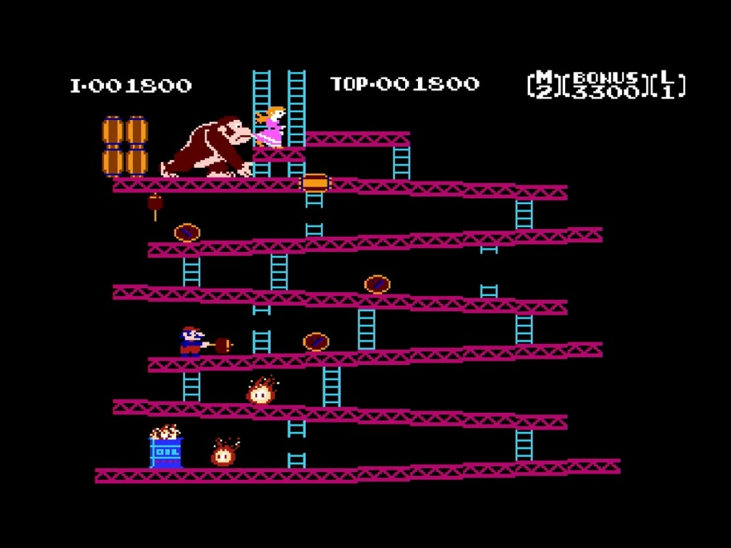

PROJECT REQUIREMENTS

Grade B

* Create an avatar who can run with A and D, and jump with SPACE bar.
* Create a setting where there are several floors at different height for player to reach.
* The avatar needs to reach the top of the setting to win.
* The player avatar’s movement and jump should involve actual forces, such as acceleration, velocity, gravity, etc.

Grade A

* Create an enemy who is constantly throwing barrels. Player will die if they are hit by the barrels. They can restart the level after dying.
* The player can jump on the buckets. And the barrels will be destroyed.
* Add a lives system, where if the player loses three lives they go to a game over screen.
* Add a score system, where destroying barrels can increase scores.

Grade S

* There are ladders between floors for players to climb. When on ladder, press “w” to climb up and “s” to climb down. The player cannot jump on a ladder.
* Add another level.
* Add a highest-score system.